Registration for Yoga Classes

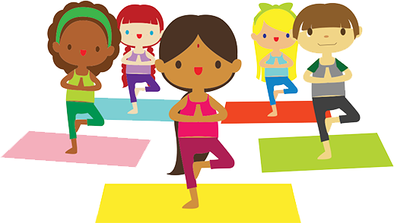

When: January 3rd – March 28th
Time: Morning
Instructor: Lisa (certified instructor)
Cost: $95.00 for 13 classes
*Bring your own mat

Name of Child: ______________________________
Payment in the amount of: $________ included
Please make check payable to Building Blocks Child Center

