Registration for 2nd Session Art Classes
“The Artful Crew” at Building Blocks
Continuation of art class we will continue to work on our fine motor skills, art vocabulary, art history, and so much more.

When: Every Tuesday 1st group 12:35 – 1:30 2nd group 1:45-2:30
January 8th – March 26th
Age: 4 year’s old
Cost: 12 classes $95.00
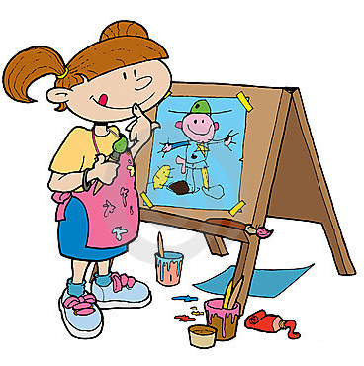
*Supplies, easels and smocks will be provided

Name of Child: ______________________________
Payment in the amount of:$________ included
Please make check payable to Building Blocks Child Center

