Registration for Art Classes
“The Artful Crew” at Building Blocks
Introduce your children to the world of art. We will guide your young child to be creative and learn art techniques. It will include art history, some great masters and their works, plus the color wheel and much more.

When: Every Tuesday 1:30-2:15
October 2nd – December 18th
Age: 4 year’s old
Cost: 12 classes $95.00 6 classes $50.00
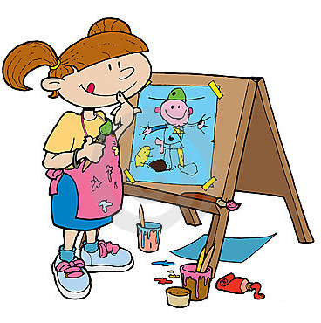
*Supplies, easels and smocks will be provided

Name of Child: ______________________________
Payment in the amount of:$________ included
Please make check payable to Building Blocks Child Center

